SE Lab 5
Reports Screenshots

Name: Prithvi Aithal
SRN: PES1UG24CS909
Class: 5G

Before:

- bandit_report.txt
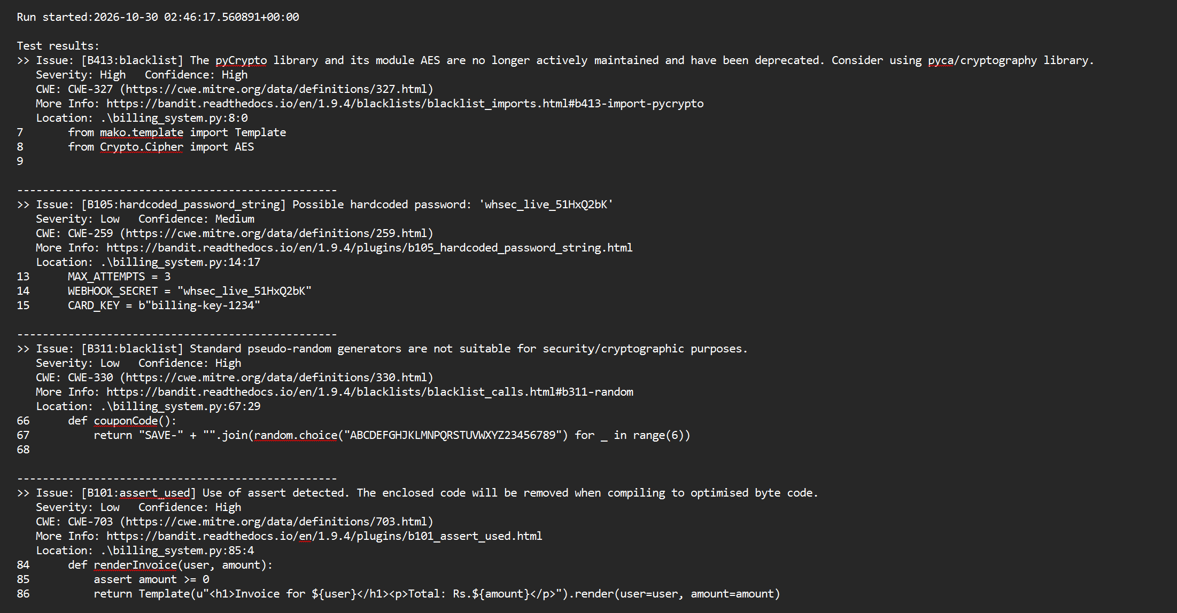
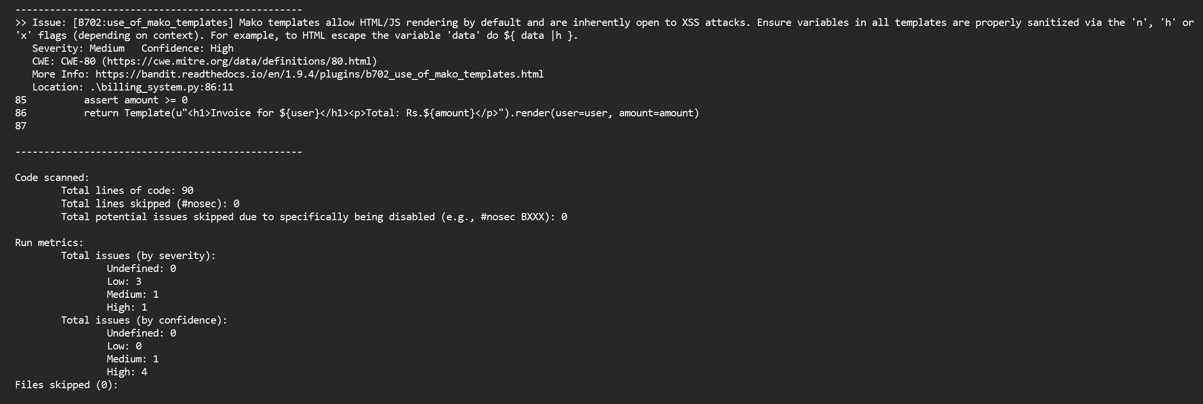
- pylint_report.txt
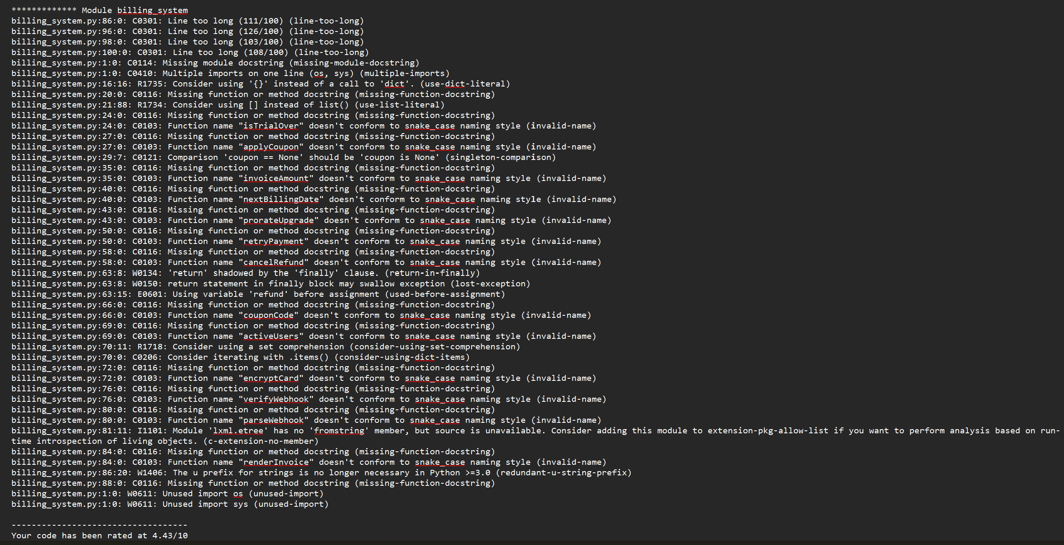
- flake8_report.txt
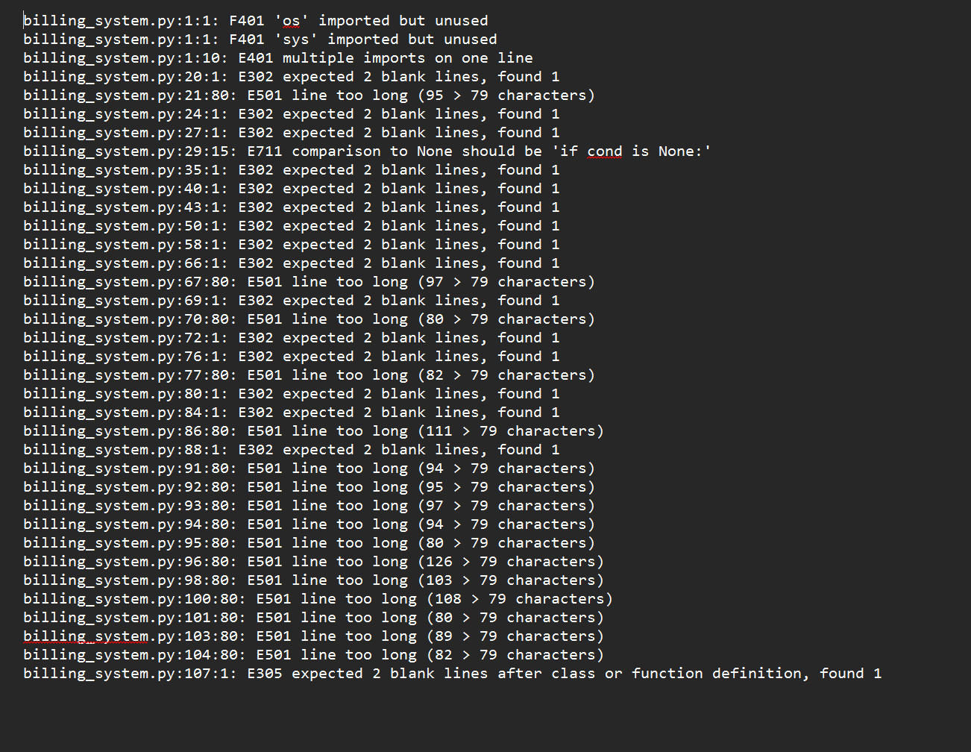

After:

- bandit_report.txt
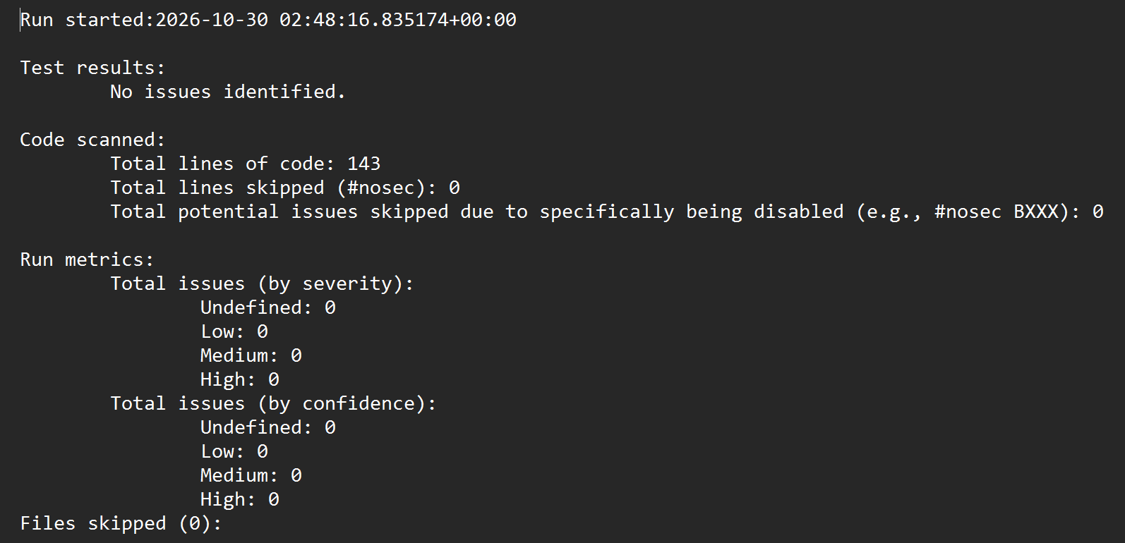
- pylint_report.txt
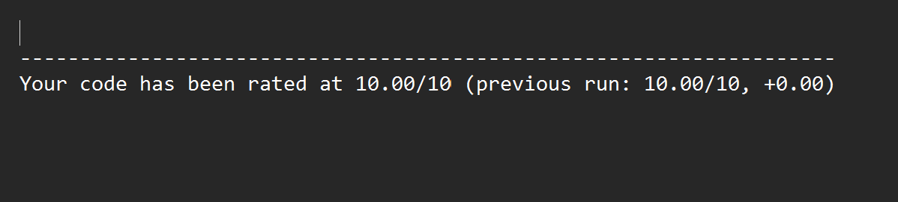
- flake8_report.txt
